**Committee: SPECPOL**

**Question: Self-Determination for Unrecognised Territories**

**Chair: Rian Shah**

**School: Habs Boys**

**Summary**

The right to self-determination is a cornerstone of international law, enshrined in the UN Charter and further supported by human rights treaties. However, many territories remain unrecognised internationally, creating complex challenges as they aim for self-governance. Unrecognised territories often emerge from historical disputes, colonial legacies, or ethnic conflicts. These regions seek either independence or autonomy but lack recognition from the United Nations or most member states. Examples include Kosovo, Somaliland, Abkhazia, and Western Sahara.

The failure to achieve recognition denies these territories access to international institutions, economic support, and legal protections, leaving them in a state of political and economic challenge. The issue is further complicated by geopolitical interests, competing territorial claims, and disagreements over the legitimacy of their aspirations. Balancing the right to self-determination with the principles of state sovereignty and territorial integrity remains a pressing concern for the international community. The international community has been reluctant to establish clear precedents for resolving such conflicts, fearing that supporting the claims of one territory could encourage separatist movements elsewhere. Furthermore, there are a plethora of examples where sovereign states supress secessionist movements, in order to seem like a unified state, often leading to violence and oppression against certain peoples.

Therefore, the question of self-determination for unrecognised territories remains a pressing issue, challenging the global community to balance the rights of peoples with the need to maintain international peace and stability.

**Definitions of Key Terms**

**Self-Determination**: The right of a people to determine their political status, pursue their economic, social, and cultural development, and be treated justly within it.

**Unrecognised Territory**: A region that declares independence or autonomy but lack a full measure of self-governance and international recognition.

**De Facto State**: Separatist entities that operate independently of a parent state but lack legal international recognition.

**Secessionist Movements**: Movements to attempt to create a new state independent of the parent state, either through violent or peaceful means.

**Territorial Integrity**: A principle under international law that sovereign states have a right to defend their borders and all territory in them from other states or secessionist movements.

**Referendum**: A direct vote by the population on a specific political issue, often used to gauge support for independence or autonomy.

**Ethnic Nationalism**: A political ideology in which a group defines its political identity based on shared ethnicity, culture, or history, often underpinning independence movements, and often emphasising ethnocentric (or even ethnocratic) approaches to political issues.

**Background Information**

The principle of self-determination has shaped international relations since the early 20th century, particularly following decolonisation movements. The 1945 UN Charter and subsequent resolutions like UNGA Resolution 1514 on decolonisation explicitly support peoples' right to self-determination. However, unrecognised territories often fall outside these frameworks, as their claims are disputed or unaligned with prevailing norms.

**Historical Examples**

* **Post-Colonial Struggles**: Many unrecognised territories emerged during the wave of decolonisation in the mid-20th century, where borders drawn by colonial powers often ignored ethnic or cultural divisions. These divisions often caused tensions between different peoples, leading to disputes over territorial claims.
* **Cold War**: Proxy conflicts during the Cold War exacerbated divisions, leading to the emergence of unrecognised states that aligned their views with rival powers. This created tensions within countries, and lead to many secessionist movements.
* **Post-Soviet Era**: The collapse of the Soviet Union in 1991 created a new wave of self-determination movements, where previous ethnic divisions where intensified. This caused more tensions between different peoples, and an increase in secessionist movements.
* **Ethnic Conflicts**: These are conflicts between one or more ethnic groups, often from political, social, or religious sources. Ethnic nationalism in a country, can mean certain policies or laws are based on ethnic or religious grounds, marginalising minority peoples in the country and creating secessionist movements. Examples include the Transnistria War and Israeli-Palestine War.

**Contemporary Examples**

* **UN Member States not recognised by at least one other UN Member State**: This is where a country is internationally recognised as a sovereign state by a majority of UN Member States, and as such is a member of the UN. They often have strong control over their territory, have diplomatic relations with many other nations, and participate in the UN. However, they are not recognised by at least one other UN Member State, often due to past or present conflicts for control of the territory. Examples include, People’s Republic of China, Cyprus, Israel and both Koreas (DPRK and ROK).
* **Nations under Special Status not recognised by at least one other UN Member State**: This is where territories are given a special status, either as a UN Observer State, or as a UN Specialised Agency Member. They often have strong control over their territory, acting as de facto states, as well as having some diplomatic relations with other nations. However, they are not legally internationally recognised by some UN Member States, and the UN itself. This is often due to ongoing tensions over the territory, such as Palestine or Kosovo; or due to legally being part of a sovereign state, such as Niue and the Cook Islands.
* **Non-UN Member States recognised by at least one UN Member State**: This is where a territory is not recognised as a separate entity by the UN, and lacks large international recognition. They often act autonomously, however are legally part of another sovereign nation, so have limited diplomatic relations with other countries and do not participate in the UN. They often exist due to large secessionist movements in a country, due to colonial ethnic divisions, or ongoing conflicts. Examples include Abkhazia and South Ossetia, Western Sahara, Northern Cyprus, and Taiwan.
* **Non-UN Member States not recognised by an UN Member States**: These territories have the least international recognition, either being recognised by only other unrecognised territories, or by no nation at all. They often illegally declare independence from a parent state and act autonomously but have very little international power or diplomatic relations. They are often caused due to colonial ethnic divisions that create conflicts over territorial claims, and can often create dangerous situations for citizens. Examples include Somaliland and Transnistria.

The key point from these contemporary examples, is that unrecognised territories are a complex problem, with multiple different statuses, levels of control, and international recognition. This means that there are no current frameworks to decide who has the right to self-determination, and who has the right to sovereignty over a territory. This creates a complex problem that requires a multi-dimensional resolution to help solve.

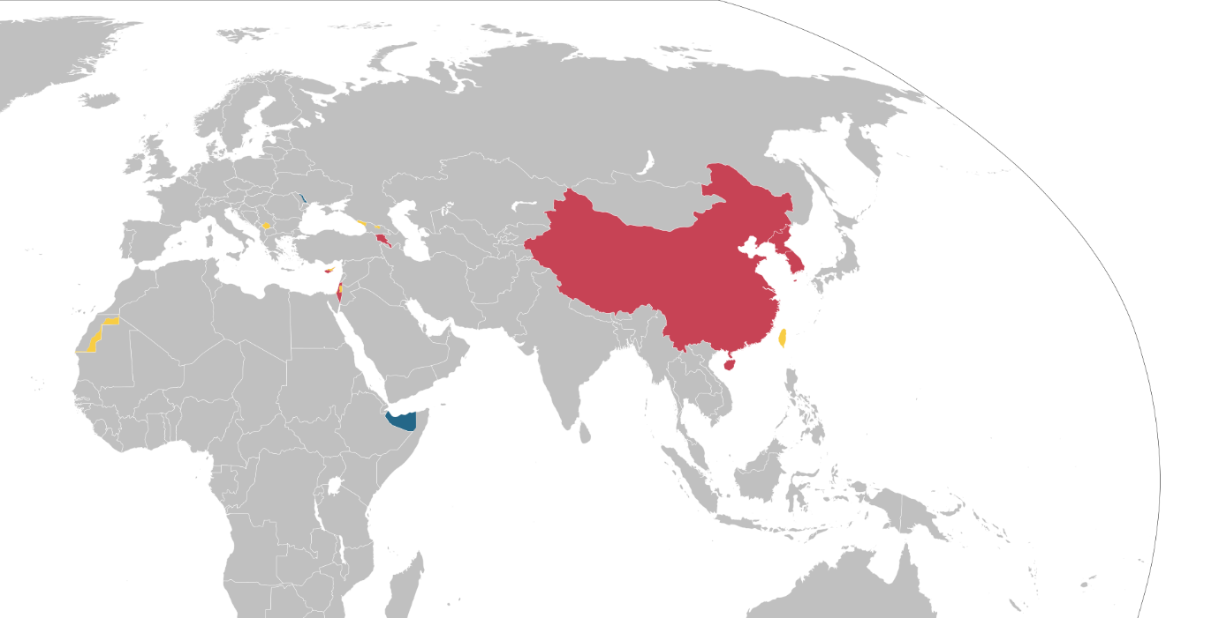

**Map of Unrecognised Territories in the World in 2024**

UN Member States that are not recognised by at least one other UN Member State

Non-UN Member States that are recognised by at least one other UN Member State

Non-UN Member States that are not recognised by any UN Member States

**Major Countries and Organisations Involved**

* **Russia**: Actively supports unrecognised territories like Abkhazia and South Ossetia, using them as leverage in regional conflicts. Also, a major cause of secessionist movements due to its part in the cold war and collapse of the Soviet Union.
* **United States**: Supports Kosovo's independence and advocates for self-determination but opposes separatist movements aligned with adversaries. Also, a cause of unrecognised territories due to its part in the cold war.
* **China**: Opposes self-determination movements, citing concerns over separatist movements in Tibet and Xinjiang. Also in a major conflict with Taiwan over the control of China, with each not recognising the sovereignty of the other.
* **African Union (AU)**: Opposes the recognition of breakaway regions like Somaliland, citing the need to respect colonial borders.
* **United Nations**: While committed to self-determination and supporting the recognition of unrecognised territories, the UN is constrained by the opinions of Member States, and by the dynamics of the Security Council.
* **Arab League**: Opposes the recognition of certain unrecognised territories in North Africa and the Middle East. It does not recognise Israel and supports the integrity of Moroccan territorial sovereignty.
* **Organisation for Security and Co-operation in Europe**: An intergovernmental organisation comprising member states in Europe, North America and Asia. Its mandate includes issues including the promotion of human rights, and free and fair elections. Believes that the right to self-determination should be respected and helps mediate peace talks between nations.

**Timeline of Events**

|  |  |
| --- | --- |
| **1776** | American Revolution occurs, leading to the earliest assertion of the right of national self-determination. |
| **1789** | French Revolution occurs, leading to the emergence of nationalism and the right for people to rule themselves. |
| **1941** | Allies of WWII declare the Atlantic Charter, accepting the principle of self-determination. |
| **1945** | UN Charter establishes self-determination as a principle, placing self-determination into the framework of international law. |
| **1947** | Indian Independence Act is passed, beginning a surge of global decolonisation movements, as well as tensions due to colonial territorial divisions. |
| **1948** | Creation of the state of Israel, leading to ethnic tensions in the region ongoing to this day. |
| **1960** | UNGA Resolution 1514 on the decolonisation of Africa and Asia. |
| **1971** | The UN recognised the PRC as the sole representative of China instead of the ROC. |
| **1991** | Soviet Union collapses, creating new self-determination claims and secessionist movements. |
| **2008** | Kosovo declares independence from Serbia, expressing it’s right to self-determination. |
| **2011** | South Sudan declares independence, using it’s right to self-determination, becoming the newest UN Member State. |
| **2016** | UNGA reaffirms support for Western Sahara's right to self-determination. |

**Relevant UN Treaties and Events**

* **Atlantic Charter (1941)**: Joint declaration released by the US and UK in 1941, to provide a broad statement of their war aims. The charter expressed both countries beliefs in the right to self-determination.
* **UN Charter (1945)**: A charter released in 1945 as an instrument of international law. It is binding by all UN Member States, and codifies the major principles of international relations. Article 1(2) and Article 55 recognise the right to self-determination, highlighting how it is vital in allowing peaceful and friendly relations between countries.
* **International Covenant on Civil and Political Rights (1966)**: The international human rights treaty adopted in 1966. Article 1 explicitly grants all peoples the right to self-determination, and to determine their political status.
* **UNGA Resolution 1514 (1960)**: Declaration on the Granting of Independence to Colonial Countries and Peoples.
* **Advisory Opinions of the International Court of Justice**: The ICJ has stated that the declaration of independence of Kosovo did not violate international law, and it did not find any legal ties affecting the independence of Western Sahara. This will shape future international debate surrounding the legality of independence, and right to self-determination.

**Previous Attempts to Solve the Issue**

**Referendums**: Some unrecognised territories have held referendums on independence, such as South Sudan in 2011 or Montenegro in 2006. Referendums can help resolve the tension between self-determination and state sovereignty, and they provide a mechanism to help the citizens voice their opinions. They require negotiations between the parent state and unrecognised territory to agree the terms of the vote, allowing the vote to be internationally recognised and binding. However, non-binding referendums, where the terms are not agreed by both parties, are very common. This is often due to referendums being held against the will of the parent state, or one party using force to change the results. This can cause more confusion on whether an unrecognised territory is independent and may lead to violence.

**Mediation and Peace Talks**: Efforts such as the Minsk Group for Nagorno-Karabakh or UN-led negotiations on Western Sahara have sought peaceful resolutions through compromises. Intermittent discussions are usually held between the parent state, unrecognised territory, and objective third parties. However, these efforts often falter due to parties having entrenched positions making it impossible to come to a compromise, or due to inconclusive outcomes from the discussions.

**International Recognition**: In 2008, Kosovo declared independence, however it is currently not a UN Member State. It is currently recognised by 104 UN Member States, out of 195, showing how there is no consensus on whether Kosovo should be allowed to become independent. This has highlighted challenges in building a consensus within the international community to either recognise or not recognise a territory. These challenges are often due to large geopolitical divides (such as the West recognising Kosovo but Russia not) and some internal issues that some countries face (such as Spain not recognising Kosovo due to numerous regional independence movements).

**Regional Support**: Unrecognised territories often rely on regional powers to sustain their government and economy, to allow them to form a society separate to the parent state. For example, Northern Cyprus relies heavily on Turkiye to fund its government and economy. This is often exacerbated by geopolitical divides, allowing regional powers to create tension and instability in opposing states. This is not a permanent solution, as it requires constant funding from external nations.

**Possible Solutions**

**UN-Led Frameworks**:

* + Establish clearer criteria for recognising self-determination claims while balancing sovereignty and stability.
  + Promote multilateral negotiations to address competing claims and resolve territorial disputes.

**Referendums and Autonomy Agreements**:

* + Advocate for internationally monitored referendums to gauge public support for independence or autonomy.
  + Encourage autonomy agreements granting greater self-governance without full independence, ensuring cultural and political rights while maintaining territorial unity.

**Economic and Development Assistance**:

* + Support economic development in unrecognised territories to reduce dependency on external patrons.
  + Create pathways for unrecognised states to access international aid and resources without formal recognition.

**Conflict Prevention and Mediation**:

* + Strengthen the role of regional organisations like the African Union or OSCE in mediating disputes between parent states and unrecognised territories.
  + Promote confidence-building measures between unrecognised territories and parent states.

**Conclusion**

The question of self-determination for unrecognised territories remains a delicate issue, intersecting with sovereignty, international law, and geopolitics. Finding a balance between recognising the right to self-determination for peoples and maintaining territorial integrity is vital. The international community must adopt flexible and inclusive approaches, ensuring that the principles of self-determination do not exacerbate existing conflicts. It is also important to note the complex nature of such a topic, with different cases often having different contexts, thus requiring unique solutions.

**Bibliography**

1. United Nations Charter: <https://www.un.org/en/about-us/un-charter>
2. International Court of Justice: Advisory Opinion on Kosovo.
3. Human Rights Watch: Reports on Abkhazia and South Ossetia.
4. African Union Policy on Sovereignty and Decolonisation.
5. [Self-Determination Integral to Basic Human Rights, Fundamental Freedoms, Third Committee Told as It Concludes General Discussion | Meetings Coverage and Press Releases](https://press.un.org/en/2013/gashc4085.doc.htm)
6. [Self-determination | Definition, History, & Facts | Britannica](https://www.britannica.com/topic/self-determination)
7. [List of states with limited recognition - Wikipedia](https://en.wikipedia.org/wiki/List_of_states_with_limited_recognition)
8. [The Compass - The Great Unravelling - The Great Unravelling: Self Determination - BBC Sounds](https://www.bbc.co.uk/sounds/play/w3csy0ws)
9. [Full article: Self-determination vs. state sovereignty. What are the determinants of agreed-upon independence referendums in liberal democracies?](https://www.tandfonline.com/doi/full/10.1080/13510347.2024.2331709#abstract)