HabsMUN Research Report on Nuclear Non-Proliferation
Committee: Disarmament and International Security Committee (DISEC)
Topic: The Question of Strengthening Nuclear Non-Proliferation Agreements
Chair: Krish Gupta
School: Haberdasher’s Boys’ School

Summary
Nuclear proliferation represents a critical global security challenge with profound implications for international peace and human survival. The potential for nuclear weapons to cause unparalleled destruction makes their limitation and eventual elimination a top international priority. Despite decades of diplomatic efforts, the global nuclear landscape remains complicated, with nine countries currently possessing nuclear weapons and ever-lurking concerns about potential nuclear weapon development by additional states.
Key impacts of nuclear proliferation include:
- Increased risk of nuclear conflict and global catastrophe
- Destabilization of regional and international security dynamics
- Potential for nuclear terrorism and non-state actor threats
- Economic burden of nuclear weapons development and maintenance
- Environmental and humanitarian consequences of nuclear weapon use
- Diversion of resources from critical human development needs
- Erosion of global nuclear non-proliferation norms
The scale and severity of nuclear proliferation risks are projected to increase without comprehensive international cooperation and robust non-proliferation mechanisms. Urgent and coordinated action is required to prevent the further spread of nuclear weapons and work towards eventual global disarmament.

Definition of Key Terms
- Nuclear Proliferation: The spread of nuclear weapons, nuclear weapons technology, or fissile material to nations not recognized as Nuclear Weapon States by the Nuclear Non-Proliferation Treaty
- Nuclear Weapon State: A state that has manufactured and detonated a nuclear weapon or other nuclear explosive device before January 1, 1967
- Fissile Material: Radioactive material capable of sustaining a nuclear chain reaction, primarily enriched uranium and plutonium
- Nuclear Threshold State: A country with the technical and scientific capability to rapidly develop nuclear weapons but has not yet done so
- Safeguards: Verification and monitoring measures designed to detect the potential diversion of nuclear material from peaceful to military purposes
- Nuclear Fuel Cycle: The comprehensive series of industrial processes involved in nuclear energy production, from uranium mining to final waste disposal
- Deterrence: A strategic military concept based on the threat of massive retaliation to prevent aggressive actions by an adversary

Background Information
The history of nuclear non-proliferation is a complex narrative of scientific discovery, technological innovation, and geopolitical strategy that emerged from the end of World War II and the subsequent Cold War period. Nuclear weapons represented an unprecedented technological breakthrough that fundamentally transformed international relations, strategic thinking, and the nature of global conflict.
The development of nuclear weapons began with the Manhattan Project during World War II, a secret American scientific initiative that successfully created the first atomic weapons. The bombing of Hiroshima and Nagasaki in 1945 marked a pivotal moment in human history, demonstrating the devastating potential of nuclear technology and ushering in a new era of global security calculations.
The post-World War II landscape was characterized by:
- Rapid nuclear weapon development by global powers
- Emergence of the Cold War nuclear arms race
- Development of the doctrine of Mutually Assured Destruction (MAD)
- Increasing scientific understanding of nuclear technology
- Growing international concern about potential nuclear conflict
- Gradual recognition of the need for global non-proliferation mechanisms
The international community's response to nuclear proliferation risks evolved through several critical stages:
- Initial attempts to control nuclear technology in the immediate post-war period
- Establishment of international diplomatic frameworks
- Development of verification and monitoring mechanisms
- Negotiation of comprehensive international treaties
- Creation of specialized international organizations to address nuclear risks
By the 1960s, the scientific and diplomatic communities had developed a more sophisticated understanding of the complex challenges posed by nuclear weapons, leading to the development of the Nuclear Non-Proliferation Treaty (NPT) in 1968.

Major Countries and Organizations Involved
- United Nations Security Council Permanent Members (Declared Nuclear Weapon States)
  - United States: Largest nuclear arsenal, ongoing modernization efforts
  - Russia: Second-largest nuclear arsenal, significant geopolitical influence
  - United Kingdom: Smaller but strategically significant nuclear force
  - France: Maintains independent nuclear deterrent capability
  - China: Modernizing nuclear capabilities with growing strategic importance
- De Facto Nuclear Weapon States
  - India: Declared nuclear weapon state, not NPT signatory
  - Pakistan: Developed nuclear weapons in response to regional security concerns
  - Israel: Suspected nuclear capabilities, maintains policy of strategic ambiguity
- Potential Proliferation Concern States
  - Iran: Ongoing international negotiations regarding nuclear program
  - North Korea: Withdrew from NPT, conducted multiple nuclear tests
- Key International Organizations
  - International Atomic Energy Agency (IAEA): Primary global verification and safeguards mechanism
  - Conference on Disarmament: Multilateral nuclear disarmament negotiation forum
  - Comprehensive Nuclear-Test-Ban Treaty Organization (CTBTO): Monitors global nuclear testing activities
  - UN Office for Disarmament Affairs: Coordinates international disarmament efforts

Timeline of Events
- 1945: First nuclear weapons used in warfare against Hiroshima and Nagasaki
- 1946: United Nations Atomic Energy Commission established to control nuclear technology
- 1953: US President Eisenhower's "Atoms for Peace" speech introduces international nuclear technology sharing concept
- 1968: Nuclear Non-Proliferation Treaty opened for signature
- 1974: India conducts first nuclear test, challenging existing non-proliferation frameworks
- 1986: Israel's nuclear capabilities first publicly revealed through whistleblower Mordechai Vanunu
- 1998: Pakistan conducts nuclear tests, escalating regional nuclear tensions
- 2006: North Korea conducts first nuclear test, triggering international condemnation
- 2015: Iran Nuclear Deal (Joint Comprehensive Plan of Action) negotiated
- 2017: UN Treaty on Prohibition of Nuclear Weapons adopted
- 2021: New START Treaty extended between United States and Russia
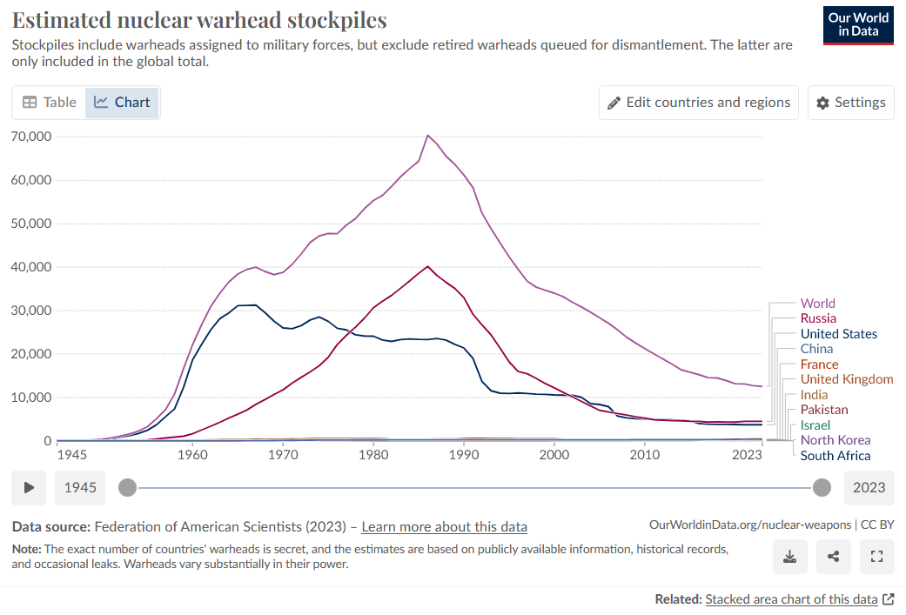
Figure 1: Global Nuclear Warhead Stockpiles 1945-2023, https://ourworldindata.org/nuclear-weapons

Relevant UN Treaties and Events
- 1968: Nuclear Non-Proliferation Treaty (NPT)
- 1996: Comprehensive Nuclear-Test-Ban Treaty (CTBT)
- 2017: Treaty on the Prohibition of Nuclear Weapons
- Ongoing: Bilateral and multilateral disarmament agreements
- Continuous: IAEA Safeguards and Verification Mechanisms
- Annual: UN Disarmament Commission meetings
- Periodic: Review Conferences for Nuclear Non-Proliferation Treaty

Previous Attempts to Solve the Issue
International efforts to address nuclear proliferation have been characterized by complex diplomatic negotiations and incrementally developed frameworks:
- Baruch Plan (1946)
  - First comprehensive proposal for international control of nuclear technology
  - Rejected by Soviet Union
  - Ultimately unsuccessful in preventing nuclear arms race
- Atoms for Peace Program (1953)
  - Proposed international atomic energy agency to control nuclear technology
  - Established foundations for peaceful nuclear energy cooperation
  - Created mechanisms for controlled nuclear technology transfer
- Nuclear Non-Proliferation Treaty (1968)
  - Fundamental global non-proliferation framework
  - Successfully limited nuclear weapon proliferation
  - Challenged by uneven implementation and compliance issues
- Comprehensive Nuclear-Test-Ban Treaty (1996)
  - Aimed to ban all nuclear explosions
  - Not yet universally ratified
  - Significant verification and enforcement challenges
- Iran Nuclear Deal (2015)
  - Negotiated agreement to limit Iran's nuclear program
  - Temporarily constrained nuclear capabilities
  - Complicated by subsequent US withdrawal and geopolitical tensions
- New START Treaty
  - Bilateral US-Russia strategic arms reduction agreement
  - Limits deployed nuclear warheads and delivery systems
  - Provides critical transparency and verification mechanisms

Possible Solutions
- Enhance Verification and Monitoring Mechanisms
  - Strengthen International Atomic Energy Agency (IAEA) inspection capabilities
  - Develop advanced technological monitoring systems
  - Create more robust international verification protocols
  - Implement real-time nuclear material tracking technologies
- Promote Comprehensive Diplomatic Engagement
  - Facilitate multilateral dialogue platforms
  - Develop confidence-building measures between nuclear and non-nuclear states
  - Address underlying regional security concerns
  - Create inclusive international negotiation frameworks
- Implement Graduated Disarmament Strategies
  - Establish verifiable nuclear weapon reduction frameworks
  - Create multilateral commitments to gradual disarmament
  - Develop transparent implementation mechanisms
  - Provide economic incentives for nuclear weapon reduction
- Address Regional Security Dynamics
  - Resolve geopolitical tensions in nuclear-sensitive regions
  - Create regional security cooperation frameworks
  - Develop alternative security paradigms
  - Implement conflict resolution mechanisms
- Technological and Economic Incentives
  - Restrict nuclear technology transfers
  - Develop comprehensive international standards for nuclear material control
  - Create economic alternatives to nuclear weapon programs
  - Provide technological assistance for peaceful energy development
- Strengthen Legal and Normative Frameworks
  - Universalize existing non-proliferation treaties
  - Develop more comprehensive international legal mechanisms
  - Enhance enforcement capabilities
  - Create more robust international accountability systems
- Promote Alternative Energy Development
  - Support renewable energy technologies
  - Reduce economic motivations for nuclear weapon programs
  - Provide technological assistance to developing countries
  - Develop comprehensive energy transition strategies

Bibliography
- International Atomic Energy Agency. (2022). Safeguards and Verification Report.
- United Nations. (2021). Treaty on the Non-Proliferation of Nuclear Weapons.
- Arms Control Association. (2022). Nuclear Weapons: Who Has What at a Glance.
- Stockholm International Peace Research Institute. (2022). Yearbook: Armaments, Disarmament and International Security.
- Comprehensive Nuclear-Test-Ban Treaty Organization. (2022). Global Monitoring Report.
- Nuclear Threat Initiative. (2021). Global Nuclear Landscape Assessment.
- Bulletin of the Atomic Scientists. (2022). Nuclear Risk Analysis Report.

Useful Links for Further Research:
- IAEA Website: https://www.iaea.org/
- Arms Control Association: https://www.armscontrol.org/
- UN Office for Disarmament Affairs: https://www.un.org/disarmament/
- Nuclear Threat Initiative: https://www.nti.org/
- Bulletin of the Atomic Scientists: https://thebulletin.org/
- Carnegie Endowment for International Peace: https://carnegieendowment.org/

