*69/

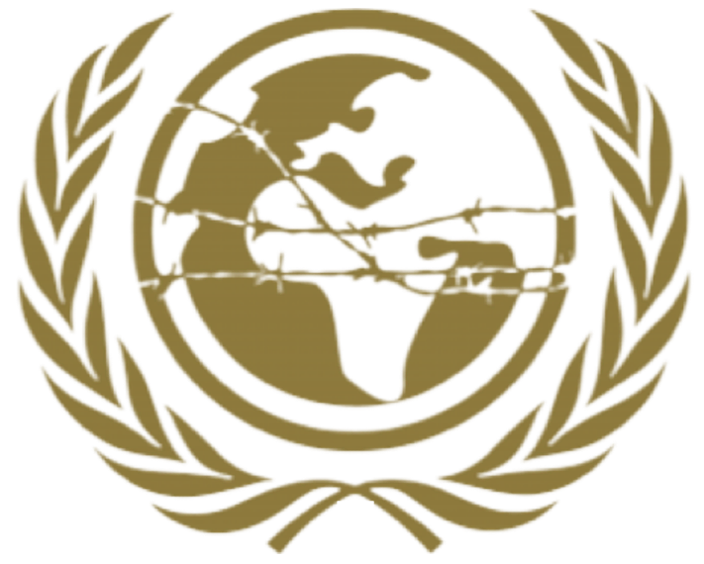

SPECPOL

Special Political and Decolonization

Freya Gordon

HABSMUN 2024

Brieﬁng paper
Committee: Special Political and Decolonization Committee (SPECPOL) Topic: The Question of Territorial Disputes in the South China Sea

Background:

The South China Sea is a strategically important body of water located in Southeast Asia, bordered by several countries including China, Vietnam, the Philippines, Malaysia, Brunei, and Taiwan. It is rich in natural resources and serves as a vital maritime trade route.

Territorial disputes in the South China Sea primarily revolve around competing claims over islands, reefs, and waters within the region. China claims sovereignty over most of the South China Sea based on historical records, while other countries assert their territorial claims based on international law and historical usage.

Current Situation:

Tensions in the South China Sea have escalated in recent years due to increased militarization, construction of artiﬁcial islands, and assertive actions by claimant states. This has led to confrontations between naval forces, concerns about freedom of navigation, and instability in the region.

China's extensive territorial claims, including its assertion of sovereignty over the entire nine-dash line, have been a focal point of contention. Other claimant states, particularly Vietnam, the Philippines, and Malaysia, have opposed China's claims and have sought international support to uphold their rights in the South China Sea.

Key Countries and Perspectives:

- China: China maintains its historical claims over the majority of the South China Sea and has pursued assertive actions to strengthen its control over disputed territories. China emphasizes bilateral negotiations and rejects international arbitration on the issue.
- Southeast Asian Countries: Vietnam, the Philippines, Malaysia, and other Southeast Asian nations assert their territorial claims in the South China Sea, often overlapping

with China's claims. These countries seek to uphold their sovereignty and rights under international law, advocating for a multilateral approach to resolving disputes.
- United States: The United States has expressed concerns over China's growing assertiveness in the South China Sea and has conducted freedom of navigation operations to challenge excessive maritime claims. The U.S. supports a rules-based order in the region and has called for peaceful resolution of disputes through diplomacy and international law.

Possible Solutions:

- Negotiation and Dialogue: Encourage claimant states to engage in peaceful negotiations and dialogue to resolve territorial disputes by international law, including the United Nations Convention on the Law of the Sea (UNCLOS).
- Conﬂict Prevention Measures: Implement conﬁdence-building measures and mechanisms to reduce tensions, such as establishing communication channels between naval forces, promoting joint resource development projects, and enhancing maritime cooperation.
- International Mediation: Explore the possibility of international mediation or arbitration to facilitate the resolution of disputes and clarify maritime boundaries in the South China Sea, while respecting the sovereignty and interests of all parties involved.

Conclusion:

The territorial disputes in the South China Sea pose signiﬁcant challenges to regional stability and security. It is crucial for all parties involved to exercise restraint, adhere to international law, and work towards a peaceful resolution through diplomatic means. The international community, including the United Nations and regional organizations, can play a constructive role in supporting efforts to address these disputes and maintain peace and stability in the South China Sea.

Useful websites:

https://www.cfr.org/global-conﬂict-tracker/conﬂict/territorial-disputes-south-china-sea https://www.csis.org/programs/asia-maritime-transparency-initiative

