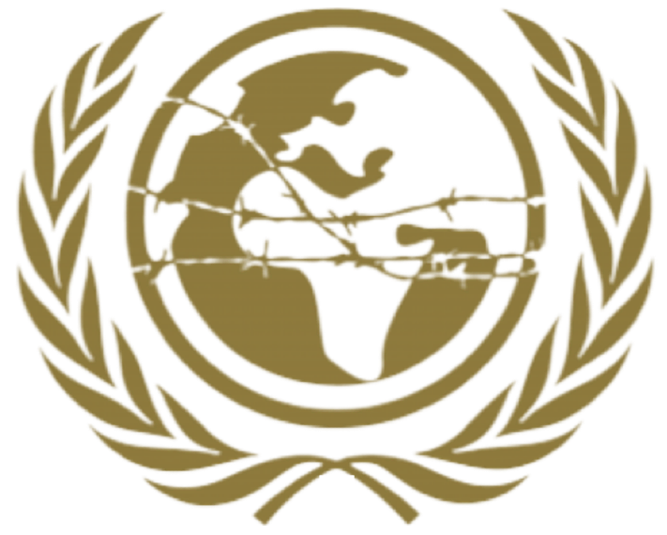

SPECPOL

Special Political and Decolonization

Freya Gordon

HABSMUN 2024

Brieﬁng paper
Committee: Special Political and Decolonization Committee (SPECPOL)

Topic: The Question of the Grand Ethiopian Renaissance Dam and Water Security Background:
The Grand Ethiopian Renaissance Dam (GERD) is a hydroelectric dam project located on the Blue Nile River in Ethiopia. It is one of the largest infrastructure projects in Africa and is intended to generate electricity for Ethiopia's growing population and economy.

However, the construction of the GERD has sparked tensions among Ethiopia, Sudan, and Egypt, as the dam has the potential to impact water availability downstream, particularly in Egypt, which relies heavily on the Nile River for freshwater.

Current Situation:

Negotiations between Ethiopia, Sudan, and Egypt over the ﬁlling and operation of the GERD have been ongoing for years but have yet to reach a comprehensive agreement. Disputes center around issues such as the pace of ﬁlling the reservoir, the management of water during droughts, and mechanisms for resolving disputes.

Egypt is concerned that the GERD could signiﬁcantly reduce its share of Nile water, which could have adverse effects on agriculture, drinking water, and economic stability. Sudan, while supportive of Ethiopia's development aspirations, also has concerns about the dam's impact on its water resources and infrastructure.

Ethiopia maintains that the GERD is essential for its development and argues that it has the right to use its water resources for hydropower generation. Ethiopia is willing to cooperate with downstream countries but insists on its sovereign right to ﬁll and operate the dam according to its timeline and priorities.

Key Countries and Perspectives:

- Ethiopia: Ethiopia sees the GERD as a vital national project that will beneﬁt its economy and people signiﬁcantly. Ethiopia asserts its right to use its water resources for development and seeks to secure a fair and equitable agreement with downstream countries.
- Egypt: Egypt is deeply concerned about the potential impact of the GERD on its water security and is seeking guarantees that its share of Nile water will not be signiﬁcantly diminished. Egypt emphasizes the need for a legally binding agreement that ensures its water rights and interests are protected.
- Sudan: Sudan supports Ethiopia's right to development but also seeks assurances that the GERD will not harm its water resources, particularly during the ﬁlling and

operation stages. Sudan advocates for a cooperative approach that addresses the concerns of all parties involved.

Possible Solutions:

- Comprehensive Agreement: Encourage Ethiopia, Sudan, and Egypt to negotiate and reach a comprehensive agreement on the ﬁlling, operation, and management of the GERD that addresses the concerns and interests of all parties.
- International Mediation: Consider the involvement of neutral third-party mediators or international organizations, such as the African Union or the United Nations, to facilitate negotiations and help bridge the gaps between the parties.
- Technical Cooperation: Promote technical cooperation and information sharing among Ethiopia, Sudan, and Egypt on water management, hydrology, and drought mitigation to build trust and enhance regional water security.

Conclusion:

The question of the Grand Ethiopian Renaissance Dam and water security is a complex issue that requires careful negotiation and cooperation among Ethiopia, Sudan, and Egypt. All parties must engage in constructive dialogue, compromise, and seek mutually beneﬁcial solutions to ensure sustainable water management and regional stability. The international community can support these efforts by providing technical assistance, mediation support, and diplomatic encouragement to reach a fair and equitable agreement.

