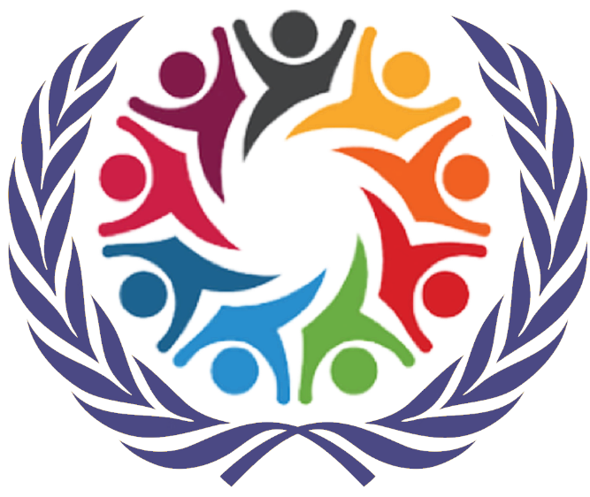

SOCHUM

Social, Humanitarian & Cultural Issues
Briefing Paper

Arjan Dhanjal
Shivam Patel
Neeam Radia
Rishikesh Trivedi

HABSMUN 2024

The Question of Improving Disability Access

Background

- Improving disability access is paramount for fostering an inclusive and equitable society. Ensuring accessibility across various domains, including infrastructure, education, employment, and technology, is not merely a matter of rights but a fundamental driver of social and economic development. By dismantling barriers and promoting universal design principles, nations empower persons with disabilities to actively participate in all facets of life, contributing their unique perspectives and talents. Enhanced disability access not only upholds the principles of dignity and equality but also aligns with broader global goals, such as the Sustainable Development Agenda, by creating environments where everyone, regardless of ability, can thrive. It is a collective responsibility to recognize, accommodate, and celebrate the diversity of abilities, fostering a world that truly leaves no one behind.

Key definitions

- Universal Design: The design of products, environments, programs, and services to be usable by all people, to the greatest extent possible, without the need for adaptation or specialized design, ensuring inclusivity for persons with and without disabilities.

- Accessibility: The degree to which a product, device, service, or environment is available and usable by people with disabilities, without the need for additional adaptations. It includes physical access, digital access, and access to information.

- Inclusive Education: A system that accommodates the diverse needs of all students, including those with disabilities, providing equal opportunities for learning and participation in mainstream educational settings.

- Assistive Technologies: Devices, tools, and technologies designed to assist individuals with disabilities in performing tasks, enhancing their independence, and facilitating their active participation in various activities.

- Reasonable Accommodation: Adjustments and modifications made in various aspects of life, including employment, education, and public services, to ensure that persons with disabilities have equal opportunities and access to participate fully.

- Civil Society Organizations (CSOs): Non-governmental organizations and advocacy groups formed by persons with disabilities and their allies, working to promote the rights, inclusion, and well-being of individuals with disabilities at local, national, and international levels.

- Inclusive Employment Practices: Policies and strategies adopted by employers to create work environments that accommodate the diverse abilities of employees, fostering equal opportunities, and eliminating discrimination in the workplace.

- Sustainable Development Goals (SDGs): A set of 17 global goals adopted by United Nations Member States to address various global challenges, including poverty, inequality, climate change, and promote inclusivity, with specific targets relevant to disability access.

- Convention on the Rights of Persons with Disabilities (CRPD): An international human rights treaty that outlines the rights and protections afforded to persons with disabilities, emphasizing their full and equal participation in all aspects of society.

- Meaningful Participation: The active involvement and engagement of persons with disabilities in decision-making processes, policy development, and implementation, ensuring their perspectives and experiences are considered and valued.

Key issues

- Legal Frameworks and Enforcement: Establishing and reinforcing national and international legal frameworks that ensure the rights of persons with disabilities are protected and implementing effective enforcement mechanisms to hold entities accountable for non-compliance.

- Infrastructure Accessibility: Addressing challenges related to accessible infrastructure design and retrofitting existing structures to meet universal design standards, including transportation systems, public buildings, and recreational spaces.

- Employment Opportunities: Implementing measures to eliminate barriers in the workplace, such as discrimination and lack of accommodations, and fostering inclusive employment practices to enable persons with disabilities to participate fully in the workforce.

- Healthcare Access: Addressing disparities in healthcare access for persons with disabilities, including the provision of accessible medical facilities, equipment, and healthcare information.

- Awareness and Attitudinal Barriers: Implementing awareness campaigns to challenge and change societal attitudes towards persons with disabilities, combatting stereotypes, prejudices, and fostering a culture of inclusivity and respect.

- Emergency and Disaster Preparedness: Developing and implementing inclusive emergency and disaster preparedness plans to ensure the safety and well-being of persons with disabilities during crises, taking into consideration their unique needs and vulnerabilities.

- International Cooperation and Knowledge Sharing: Encouraging collaboration among nations to share best practices, research, and technologies related to disability access, fostering a global community committed to continuous improvement and inclusivity.

Timeline

- 1945: The establishment of the United Nations marked the beginning of global cooperation on various issues, laying the foundation for future efforts to address disability rights and accessibility.

- 1982: The World Programme of Action Concerning Disabled Persons was adopted by the United Nations General Assembly, outlining a global strategy for enhancing the full and equal participation of persons with disabilities in society.

- 2006: The Convention on the Rights of Persons with Disabilities (CRPD) was adopted by the UN General Assembly, providing a comprehensive international framework to protect and promote the rights of persons with disabilities. The CRPD entered into force in 2008.

- 2010: The UN Global Survey on Disability was conducted, highlighting the need for more comprehensive data on disability to inform policy and programming.

- 2011: The UN Secretary-General launched the UN Partnership to Promote the Rights of Persons with Disabilities (UNPRPD), fostering collaboration between UN agencies to advance disability-inclusive development.

- 2013: The High-Level Meeting of the General Assembly on Disability and Development emphasized the inclusion of disability issues in the post-2015 development agenda, paving the way for the integration of disability perspectives into the Sustainable Development Goals (SDGs).

- 2015: The 2030 Agenda for Sustainable Development was adopted, featuring the inclusion of disability-specific targets and indicators within several SDGs, emphasizing the commitment to leave no one behind.

- 2018: The UN Disability Inclusion Strategy was launched to guide the organization's efforts in becoming more inclusive and accessible, both internally and externally.

- 2019: The UN General Assembly adopted the first-ever resolution on the rights of persons with disabilities in armed conflict situations, recognizing and addressing the heightened vulnerabilities faced by individuals with disabilities during conflicts.

- 2020: Amidst the COVID-19 pandemic, the UN emphasized the importance of considering persons with disabilities in response and recovery efforts, recognizing the unique challenges they face during health emergencies.

Previous action

- Adoption of the Convention on the Rights of Persons with Disabilities (CRPD): The CRPD is a landmark international treaty that sets out the rights of persons with disabilities and emphasizes the importance of accessibility in various aspects of life, including education, employment, and public services.

- World Programme of Action Concerning Disabled Persons: This program outlined a global strategy to enhance the full and equal participation of persons with disabilities in society, emphasizing the need for barrier-free environments and inclusive policies.

- International Day of Persons with Disabilities: Designated by the UN, December 3rd serves as a day to promote awareness and mobilize support for the rights and well-being of persons with disabilities. Each year, a specific theme is chosen to focus attention on a particular aspect of disability rights.

- The Incheon Strategy: Adopted at the Asia-Pacific Ministerial Conference on Disability, this strategy aimed to make the region more disability-inclusive by promoting accessible environments, social protection, and participation in political processes.

- Global Survey on Disability: Conducted by the UN, this survey assessed the status of persons with disabilities worldwide, providing valuable data to inform policy and advocacy efforts on disability rights and inclusion.

- 2030 Agenda for Sustainable Development: The inclusion of disability-specific targets and indicators within the Sustainable Development Goals (SDGs) underscores the commitment to leaving no one behind, emphasizing the importance of disability inclusion in global development efforts.

- UN Partnership to Promote the Rights of Persons with Disabilities (UNPRPD): Launched by the UN Secretary-General, this partnership facilitates collaboration between UN agencies to advance disability-inclusive development.

- UN Disability Inclusion Strategy: This strategy aims to strengthen the UN's internal and external disability inclusion efforts, promoting accessibility and eliminating barriers for persons with disabilities within the organization and its activities.

- Convention on the Rights of Persons with Disabilities in Armed Conflict: The UN General Assembly adopted the first-ever resolution addressing the rights of persons with disabilities in armed conflict situations, recognizing and addressing the unique challenges faced by individuals with disabilities during conflicts.

Questions to consider

- Policy Implementation: How can member states ensure the effective implementation of national policies and action plans aimed at improving disability access, and what measures can be taken to enhance accountability for adherence to these policies?

- Meaningful Participation: In what ways can the UN support and promote the meaningful participation of persons with disabilities in decision-making processes related to disability access at local, national, and international levels?

- Resource Allocation: What strategies can be employed to encourage member states to allocate sufficient financial and human resources for the implementation and monitoring of disability access initiatives, and how can international collaboration facilitate resource sharing?

- Legal Frameworks: How can the UN assist member states in developing and strengthening legal frameworks that protect and promote the rights of persons with disabilities, with a specific focus on ensuring accessibility and eliminating discrimination?

- Education Inclusivity: What steps can be taken to enhance inclusive education practices globally, ensuring that students with disabilities have equal access to quality education, including accessible learning materials and trained educators?

- Private Sector Engagement: How can the UN facilitate collaboration between member states and the private sector to promote inclusive employment practices, including reasonable accommodations and the removal of barriers to workforce participation for persons with disabilities?
- Global Data Collection: What initiatives can be implemented to improve the collection of comprehensive and accurate data on disability, ensuring that information is utilized to inform evidence-based policies and programs?

- Assistive Technologies: How can the UN encourage the development, affordability, and accessibility of assistive technologies on a global scale, promoting innovation and addressing the specific needs of persons with disabilities?

- Awareness and Attitude Change: What role can the UN play in fostering global awareness campaigns to challenge and change societal attitudes towards persons with disabilities, combating stereotypes, and promoting a culture of inclusivity and respect?

- Emergency Preparedness: How can the UN support member states in developing and implementing inclusive emergency and disaster preparedness plans to address the unique vulnerabilities of persons with disabilities during crises?

Useful links

Disability Inclusion in the United Nations System

Disability Inclusive Response to COVID-19

What is the UN CRPD?

