DISEC
Disarmament and Security Briefing Paper

Zain Hasan Matthew Wong

HABSMUN 2024

Question of the Weaponization of the Colonisation of Outer Space
As space exploration gets more sophisticated, outer space and space weapons are becoming more readily available to an ever-broadening range of countries and companies. International law has therefore found a growing urgency to define the possibility and the bounds of space war. The increasing militarisation of space has gotten to the point where as many as 75% of space satellites are stationed for military function - the vagueness of the figure comes from the fact that communication satellites, which are not ordinarily made to serve such a purpose, may become used to coordinate military efforts on Earth should the situation arise. You should know that a space weapon is defined as any Earth-based asset used to attack targets in space, as well as any space-based asset designed to attack targets on Earth.

Key issues

Increasing Privatisation of Space

The Freedom Principle of the Outer Space Treaty, which we’ll expand upon later, essentially helped to make space more accessible to a broader range of nations and companies, including the private sector. The increasing privatisation of space has encouraged the use of dual-use technology, that is to say technology that serves both a civilian and a military function. Passive military activity and peaceful scientific purposes have therefore become intertwined, and so in your resolution, you should explore to what extent your country believes this is problematic or beneficial, and what you might do to put your viewpoint into action. For instance, you could say this is bad because dual-use technology can be deceptive and can encourage the use of space weapons, but on the other hand, this sort of cooperation has proven to be essential for ensuring efficient space exploration (e.g. many scientific exploration efforts on celestial bodies may be done by establishing scientific military bases).

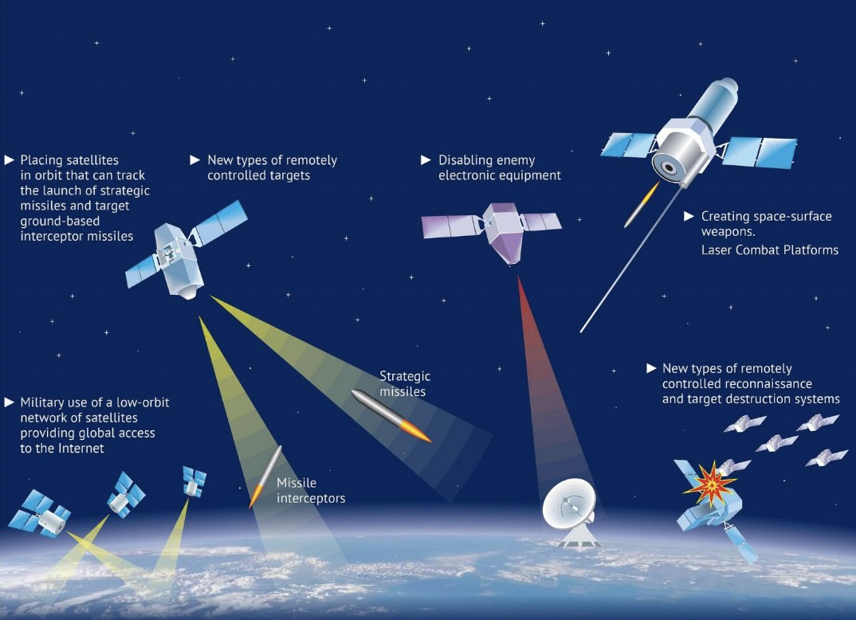
Technological Advancements

Technological advancements have caused space to get much more competitive. Larger geostationary satellites are being projected into the Earth’s orbit, and these advancements are for the most part beneficial, but weapons technology has been getting more sophisticated as well. ASATs, or anti-satellite weapons, have been tested by China, the USA, Russia and India, and because satellites are

crucial to daily life on Earth, it goes without saying that ASATs pose a huge risk to terrestrial safety. The problem is made worse by the fact that existing systems only require minor modifications to act as ASATs, meaning space weapons are now more accessible than ever before. Think about how your resolution will tackle the increasing accessibility of space weapons, the development of anti-satellite technology, and the growing deployment of dual-use systems into the Earth’s orbit.

Increasing Reliance on Space

This ties in with one final problem, that being that as technology develops, everyone on Earth increasingly relies on satellites, making them very attractive targets for space wars. To attack a satellite would mean disruption of international communications, which would quickly cause the world to descend into chaos. Though there are plenty of legal frameworks that address this issue, you should consider the relationship between this problem and the increasing privatisation of space - private actors can indeed pursue their own corrupted interests in violation of space law. What will your resolution do to combat this, while giving private actors the autonomy to develop technology without government funding?

Some other key topics you should explore in the weaponization of outer space include the stationing of military equipment in outer space, the rise of dual-use technologies in space, and the problem of space debris created by space weapons which threatens the continued use of outer space considering that there is no current reliable method for clearing it. Space debris is also created by kinetic energy weapons (i.e. weapons which disintegrate their target) and directed energy weapons (i.e. those which use lasers and particle beams to disable satellites). Your resolution may want to address these problematic weapons, the harmful space debris which they cause and the countries which possess them. Remember to look into the following legal frameworks so that you’re informed on the current legality of the usage of such weapons.

Legal Frameworks

The Outer Space Treaty (OST)

The OST states under the Freedom Principle that all outer space activities “should be conducted for the benefit and interest of all countries, irrespective of their degree of economic or scientific development”. Its name comes from the fact that all states are free to explore outer space in line with equality and international law. It also enforces a policy of partial demilitarisation, expressly prohibiting the stationing of nuclear weapons or weapons of mass destruction in the Earth’s orbit, while also placing limits on the construction of military bases on celestial bodies. This treaty also sets out various crucial secondary obligations - all States must conduct space activities in line with the Charter and International Humanitarian Law (IHL), and that international consultation on harmful space activities under Article IX may be put into effect if a state feels that another State Parties’ actions have been in violation of the OST. One of these obligations include the prohibition of a bilateral conflict in space, due to the simple fact that an armed conflict in space would be so materially destructive its ramifications would be

almost irreversible. The OST ultimately emphasises the peaceful use and exploration of outer space before all else. This document is thus something crucial to bring up in your resolution when discussing the extent to which weaponizing outer space is legal or justifiable under currently existing international law.

The Charter

The Charter is the leading document for maintaining peace and security. It presumes that force will not be used where this would be unjustifiable or unlawful, and crucially, it does not prohibit the development or stockpiling of space weapons, nor does it state that non-aggression is breached by testing or deploying space weapons for national security during peacetime without explicit or implied threat of using them. Self-defence is a right which the Charter expands upon, stating that this right only comes about in the event of an armed attack. Crucially, anticipatory self-defence (i.e. using force against an imminent attack) is within international law under the Charter, but pre-emptive self defence (i.e. using force against remote threats or suspicions) is not. You might like to address the relationship between self-defence and the weaponization of outer space under the context of these frameworks, and it would be especially perceptive to bring up examples of self-defence in historical conflicts and how you may think this could play out in a space war.

International Humanitarian Law (IHL)

IHL is another important legal framework which specifically aims to limit suffering during wartime, rather than determine whether a war is legal or not (that would be in the jurisdiction of the Charter). It is based on four principles, the most relevant ones to this topic being distinction, meaning civilians cannot be made the target of an attack; proportionality, meaning military advantage must be balanced by damage to non-combattants; and humanity, which is rather self-explanatory. IHL is codified by the Geneva Conventions and their Additional Protocols, one of which (API) specifically prohibits methods of warfare that may cause widespread, long-term and severe damage to the natural environment, which may be relevant to the weaponization of outer space (this is also elaborated upon by another convention, ENMOD, which you might like to look into). The best resolutions will delve into the implications and potential scope of space war and the extent to which it may be in violation of IHL and the Geneva Conventions.

Other frameworks

The Liability Convention states that liability for damage caused on Earth’s surface or caused to aircraft in flight by space objects falls upon the state which launched the object. The Rescue Agreement specifies the recovery and return of astronauts, emphasising that they may not engage in hostilities during space wartime otherwise they qualify as prisoners of war. There is also the Registration Convention which delineates a mechanism by which space objects can be identified, essentially expanding the scope and practical effect of the OST. There are other proposals that haven’t come into effect, such as the Chinese and Russian proposal, which is continually rejected by the USA, and the EU Policy Proposal, rejected by the USA, China,

Russia and India. Definitely look into why they rejected them, and analyse whether you feel this is justifiable under what your country believes.

Writing your Resolution
If you want to make an effective resolution under this topic, consider the following points:

- How would your country view the weaponization of outer space? Is your country a ‘space power’ that may encourage it, or a more pacifist nation that would rather encourage the peaceful exploration of space?
- How does your country view the problems of the privatisation of space, the development of anti-satellite technology, dual-use systems etc? Does your country give funding to companies that develop this technology? Is your country a signatory of treaties that would prohibit the development of such technology?
- What does your country propose the world (or specific countries) should do to mitigate the threat of space war in the form of the problems above? Remember to be specific when describing these policies.
- What legal frameworks will you use to substantiate your points?
- Will you establish a UN subcommittee to help enact your resolution?
- How will other countries react to your resolution? How can you anticipate and mitigate their impact? How important is this to take into consideration?

Remember to produce a resolution and a position paper of ~100 words to inform your country’s stance on this Question. There are many more things you can discuss - explore as much as you can and have fun with it!

Further Reading

Defining and Regulating the Weaponization of Space
Space Weapons, the Increasing Militarisation of Outer Space and its Legal Frameworks An Actual Summary of a UN Committee Hearing on this Question
The OST and the Weaponisation of Space
Summary of UN bodies, Legal Instruments and Key Issues of this Question

