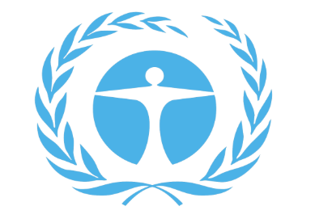
Committee for Environment Protection

Briefing Paper

Zakariya Tanweer
Ali Moussa
HABSMUN 2024

Hi, my name is Zakariya Tanweer, and I will be the head chair of the Committee for environmental protection. I am looking forward to some productive and thought-provoking debate. HabsMUN provides a great opportunity for young people to get a feel for what a real UN conference would be like, but I’m sure you already knew that!
If you have any queries or questions about MUN or the upcoming debate please do not hesitate to ask, just send an email to me, at tan001@habsboys.org.uk
What do you need to do?
As part of being a delegate you are required to produce a position paper. A position paper should be a short summary, (less than a page in length) detailing the policies and procedures of your country that regard to a certain topic. It is always a good idea to write a position paper because it helps to get a better idea of the actions you should take in committee while representing your country, conversely, it’s also kind of awkward to not have one when we ask you to make an opening statement...
In this case the questions are on marine life protection, fast fashion, and solutions for sustainable development. Your position paper should then be emailed to me prior to the debate. As well as the position paper, we ask you to produce a resolution paper on what your country aims to do about the selected issue. Resolution papers, though not obligatory, enhance the whole experience and create a more realistic conference, as to why we urge you to write one. Your resolution papers can be brought with you on the day, but it would be incredibly helpful if you could also send me a copy of your resolutions before the debate.
(We ask that you provide a separate position paper and resolution paper for each topic that we are debating to reduce chances of confusion.)

Questions of debate
The three questions in debate in CEP are:
- The Question of the Protection of Marine Life and Coral Reefs
- The Question of Fast Fashion
- The Question of Nature-based Solutions for Supporting Sustainable Development
Background Information
We are in the middle of a climate crisis. Our climate is changing in unprecedented ways and that’s a culmination of lots of factors, we can’t underestimate fast fashion’s impact on the environment. These commercial trends release 1.2 billion tonnes of CO₂ every year, making up 10% of global emissions. As clothing degrades in landfills it releases methane, a potent greenhouse gas that is 28 times more powerful than carbon dioxide. And that’s just fast fashion…
Globally, oceans are changing. Ocean warming (0.88°C higher in 2011-2020 compared to 1850-1900), oxygen loss (down 3-4% by 2100) and ocean acidification (decreased pH by 30% in 2023 compared to 1700) may be occurring at a speed that may be too fast for species to adapt to the changes – if we don’t implement some serious change. Ergo sustainable development mechanisms.
What are the global impacts of global warming?
Our sea levels are rising due to the melting of glaciers and thermal expansion which are both side effects of our rising global temperature. Between the 1880s and the 1980s global temperature was increasing, on average, by around 0.07 degrees Celsius every year. Since the 1980s, global temperature has been annually increasing by around 0.17 degrees Celsius and 9 out of the 10 hottest years on record have all occurred since 2005. With CO2 emissions still high and a dramatic reduction in them nowhere in sight our global temperature is likely to continue rising and it is not just sea levels that are being affected.
Land aridification is also occurring and is the process in which areas of land are becoming desert, some studies even predicting that as much as thirty percent of the land on earth was at risk of aridification. This could lead to major problems in the areas affected such as malnutrition due to the struggle or complete inability to grow crops on arid land.
When writing your resolution, you should consider:
If your country going to be directly impacted by climate change. Does your country host diverse marine life? Do you export massive amounts of clothing, or propagate a fast fashion culture etc. If so, then how do you plan on mitigating environmental damage?
- Does your Dictator/President/Prime Minister/Parliament believe in the climate crisis?
- Will your country take preventative action?
- What will your national response be targeted towards corporate organisations?
- What should the international response be?
The Question of Nature-based Solutions for Supporting Sustainable Development:
- Try to keep your solutions precise with detailed mechanisms. Being ambiguous is a sure route to questioning from other delegates in open debate!
- How can we get local communities to engage with nature-based frameworks?
  - Does this mean that there needs to be better access to environmentally friendly resources for cheaper, to allow local businesses to keep competitive viability with their products as well?
- How do the mechanisms you’ve suggested fit in with the sustainable development goals?
- Think about how nature based how solutions like planting trees can reduce greenhouse gas emissions. According to the International Union for Conservation of Nature (IUCN), natural ecosystems can absorb 11 gigatons of carbon dioxide annually, highlighting the potential of nature based solutions in climate action.
- Nature based solutions also play a crucial role in conserving biodiversity and protecting ecosystems. The World Wildlife Fund (WWF) reports that ecosystems provide essential services worth an estimated $125 trillion annually, underlining the economic value of biodiversity and the importance of Nature based solutions in safeguarding ecological integrity.
- Ecosystem-based approaches enhance resilience to natural disasters by maintaining natural buffers and promoting green infrastructure. The United Nations Environment Programme (UNEP) estimates that mangroves alone can reduce wave heights by up to 66% during storms, demonstrating the protective role of natural habitats in disaster-prone areas.
- Finally consider if nature-based solutions might contribute to poverty alleviation. According to The World Bank, the implementing Nature based solutions could directly benefit the livelihoods of over 1.6 billion people who directly depend on forests for their subsistence and income.
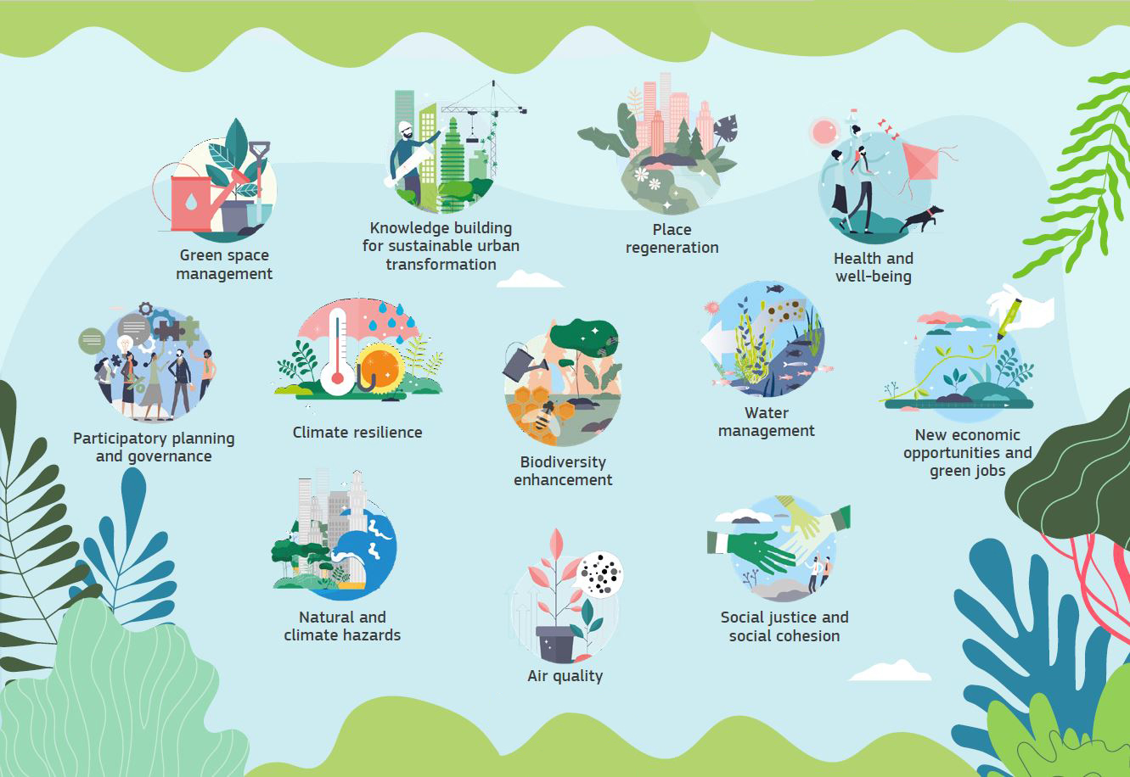
Non-exhaustive list of useful websites
https://www.nationalgeographic.com/environment/global-warming/sea-level-rise
https://www.eea.europa.eu/publications/how-climate-change-impacts#:~:text=Globally%2C%20oceans%20are%20changing.,to%20adapt%20to%20the%20changes.
https://education.nationalgeographic.org/resource/ocean-impacts-climate-change/
https://www.unep.org/news-and-stories/story/environmental-costs-fast-fashion
https://climate.nasa.gov/vital-signs/global-temperature/
https://www.climate.gov/news-features/understanding-climate/climate-change- global-sea-level

This might be of some use as well:
https://www.un.org/en/model-united-nations/drafting-resolutions

Good luck!
(and don’t use chatGTP)

