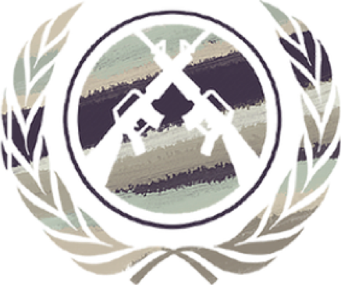

DISEC
Disarmament and Security Briefing Paper

Zain Hasan Matthew Wong

HABSMUN 2024

Question on the Availability of Arms in Libya

Context and Background Information
In 2011, Muammar Gaddafi was deposed from his rule over Libya. Up until then, the country had been transformed into one of the most highly developed nations in Africa, but Gaddafi’s methods to achieve this, using rampant censorship and corruption, provoked the First Libyan Civil War. This lasted a year and saw the rise of the Transitional National Council, tasked with transitioning Libya into a democratic constitution. Since this transition was never achieved, a coup d’état launched by the Libyan National Army (LNA) took place marking the beginning of the Second Libyan Civil War, during which numerous parties including the UN-backed Government of National Accord (GNA), the LNA, the House of Representatives and the Islamic State all had a role in causing rampant instability. The war was brought to an end in 2020 with a permanent agreement signed between the LNA and the GNA, but with democratic elections continuing to be withheld, threats of a new civil war are on the horizon.

Back to DISEC, though - after Gaddafi was overthrown in 2011, numerous stockpiles of small arms and light weapons (SALWs) were looted, causing a flow of somewhere between 250,000 - 700,000 SALWs across Libya and, soon enough, into neighbouring conflict zones. With further weapons supplying the GNA (mostly from Turkey and Qatar) and the LNA (mostly from the UAE, Jordan, Russia, Egypt and France) after this date, the GNA and the LNA continue to get their arms from illicit arms routes from all aforementioned nations today. For example, Russia’s Wagner group, a paramilitary group, has been known to operate in Libya, attracting controversy over their laying of IEDs and landmines in the nation. Since 2019, most arms deliveries have involved military vehicles, offshore patrol vessels, unmanned armed vehicles (UAVs) and even jamming systems and surveillance, showing that Libya is concerningly becoming a playground for the testing of new military technology. Arms from at least 12 countries have been known to circulate amongst Libya - you should identify whether your country is one of them to nuance your viewpoint on this Question.

The spread of SALWs into neighbouring countries slowed after 2014 as the local demand for arms in Libya increased as a result of the GNA’s commencement of their operation against
Al-Qaeda and ISIS. This period also saw Operation Barkhane in Mali, Niger, Chad, Mauritania, Burkina Faso and France. This was a counterinsurgency operation which helped to impair major smuggling routes in the region. However, the increased intensity of fighting in Libya during this time boosted the demand for weapons internally for all factions, including for civilians. Firearms therefore became offered much more openly, with negotiations and purchases even being made on social media platforms such as Facebook. With civilians now implicated in the availability of arms in Libya, the impact of the illegal arms trade has become more permanent. Chadian and Sudanese armed groups have shown intensified fighting recently as well, and with the domestic demand for arms in Libya having decreased due to the end of their civil war, arms routes through Niger and Chad are now much less hindered than in the past. The end of the Libyan Civil War is also marked by the military buildup of neighbouring Algeria and Egypt.

Key issues

Worsening adjacent conflicts

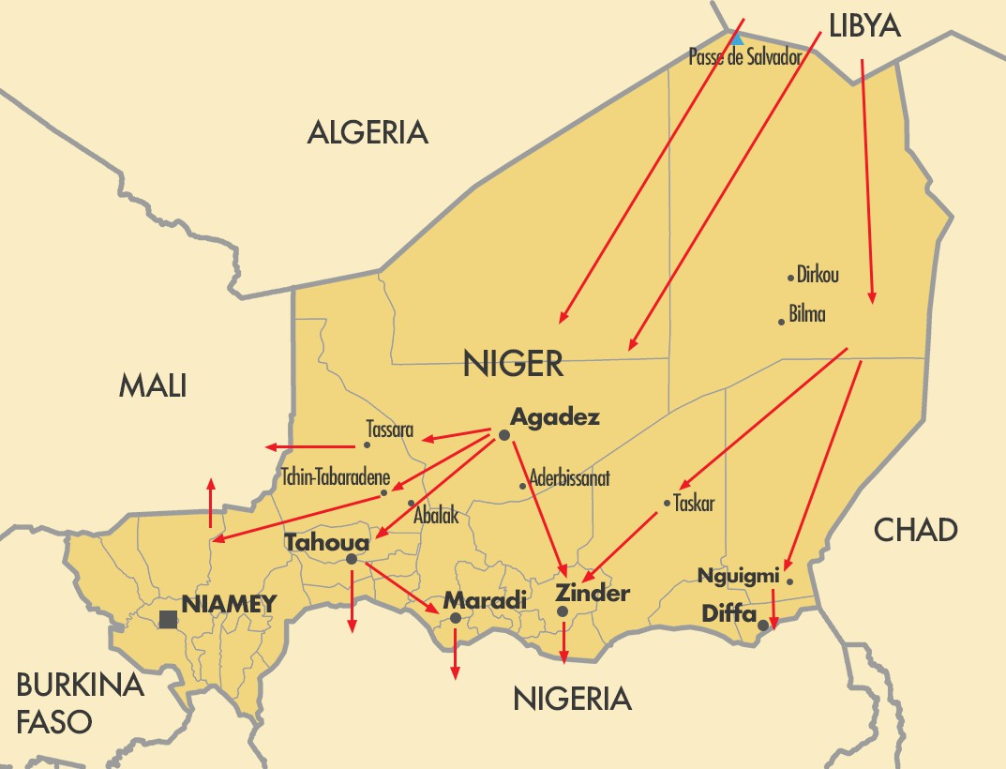
As alluded to already, the availability of arms in Libya has opened up numerous illegal arms trade routes through Africa, having direct impacts on nations in the Sahel region where armed groups (e.g. Mali’s Tuareg rebels, the Union of Resistance Forces in Chad, the Niger Movement for Justice) and terrorist organisations (e.g. Boko Haram in Nigeria) use the newfound availability of weapons to advance their agendas.
Most notably, in Mali, Libyan weapons helped to form a rebel coalition in 2012 which would go on to topple the
democratic government for a jihadi alliance to take control in its place.

Despite numerous UN-imposed arms embargoes stretching from 1973 to 2011, over 12 countries have received illicit transfers of arms “including man-portable air defence systems (MANPADs), small arms and related ammunition and explosives and mines” according to the UN Security Council. According to another UNSC report, the majority of Libyan arms stockpiles were controlled by non-state armed actors, identifying Libya as a primary source of illicit arms. This will have therefore directly impacted Levantine conflicts, particularly the Syrian Civil War and reconstruction efforts post-conflict. Some countries like France, the UAE and Qatar have all been involved in giving arms to Libya to further their geopolitical interests, helping to worsen this problem across the board. Your resolution must address this issue - how would you stop this flow of arms? How would you ensure that militias don’t gain their arms from other illicit sources? Would your country even want this to happen at all? What other committees will you enlist or create to regulate the threat of rising insurgency?

Instability and Human Rights Violations

Furthermore, Libyan arms flows cause widespread instability in the nations supplied. In 2014, when the arms flows began slowing down, Jihadist groups had to get their arms from elsewhere, and so they attacked army barracks in Mali, Niger and Burkina Faso to fill the void, expanding the domain of political instability in these nations. On 21 March 2021, armed bandits killed 137 people near the Niger-Mali border, prompting inhabitants of nearby regions to arm themselves in self-defence. The arms they used were likely supplied through this illegal arms flow, highlighting exactly who benefits from Libyan arms being smuggled across borders - terrorist organisations and militias - creating the perfect environment for civil war and societal fragmentation to take place.

To twist the knife, arms traffickers sell their arms to civilians for self-defence to capitalise off the fear that inhabitants feel towards the ever-increasingly armed militias they supply, creating a lucrative source of trade that only strengthens arms trafficking routes. These routes are worryingly even beginning to evade US surveillance systems put in place to catch them out.
With the power of these militias subsequently increasing, human rights violations are at an all time high, with over a million people in Burkina Faso living in areas controlled by armed groups which threaten them daily. This is accompanied by widespread closure of schools and by reports of rape, sexual violence and torture multiplying according to a July report from the UN Security Council. The best resolutions will directly address how instability will be mitigated and which UN subcommittees will be enlisted to help with this change. Being such a complex issue, the best resolutions will tackle many economic and social factors to make themselves fit for enaction.

Legal Frameworks

Arms Trade Treaty (ATT)

The ATT is a multilateral treaty which aims to regulate the international trade in conventional weapons. It aims to combat the effect of reckless arms proliferation, imposing strict rules on international arms transfers. The efficacy of the ATT has been called into question - for one, some of the largest arms exporters like Russia have not signed it. More relevant to this topic, Egypt, the UAE and Saudi Arabia have all not signed the ATT, and Libya and the USA have not ratified it either. Secondly, many countries who have signed the treaty do not comply with what it mandates, calling into question whether the treaty is even worthwhile. You might like to explore this question in your resolution, as well as what specific articles in the ATT you will use to justify your position.

Though the ATT is the main legal framework for this Question, some others to explore and analyse would be the Convention on Cluster Munitions, the Convention on Certain Conventional Weapons and the EU Common Position on Arms Exports. These are all linked in the Further Reading section. Good luck, and happy writing!

Further Reading

Libya: Arms Proliferation and Armed Groups Amnesty International: The Arms Trade Treaty Arms Trafficking from Libya to Niger
Overview of the Second Libyan Civil War Human rights violations in the Sahel
The EU Common Position on Arms Exports
The Convention on Certain Conventional Weapons The Convention on Cluster Munitions

